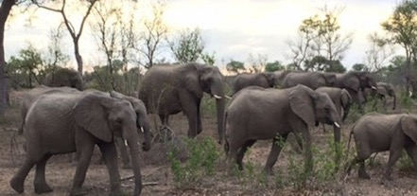Awakening your African soul
with Ruth Underwood
South Africa
26th September – 11th October 2017

South Africa is an exquisite country full of beauty and warmth. Its landscapes are breathtaking and the energy of the land, animals and its people will enfold you. This journey is designed to give you a wide variety of experiences and a deep immersion into your connection with the land, nature spirits, and the wild African animals.

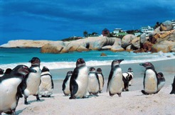
Cape Town: We begin our journey in the unique urban geography of Cape Town with a visit to the top of Table Mountain, one of the 7 new natural wonders of nature. At over 260 million years old, Table Mountain is one of the oldest mountains in the world. Held in this nurturing and revitalizing energy we’ll explore the chakras of the Cape Peninsula with a hike in the mountains to ancient caves and burial sites, a journey to Cape Point, and a visit to the penguin colony at Boulders Beach.

Johannesburg: A short overnight stay in the vibrant city of Johannesburg, a melting pot of many races and cultures. An opportunity to visit the Origins Centre and to shop in the local neighbourhoods and african market.

Mpumalanga: From the urban we head northeast to Mpumalanga province - the place where the sun rises. Here we are able to relax into the majesty and oneness of the natural world and meet with the animal kingdom. Our first stop is a a visit to the quaint village of Kaapsehoop, visiting sacred sites nearby.
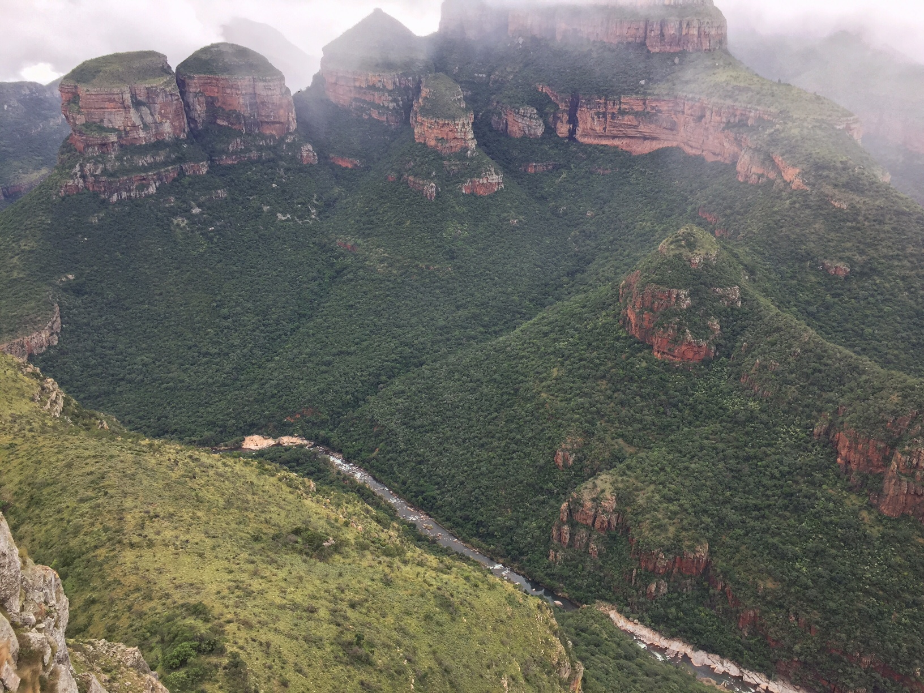
We spend two nights at a bush lodge where we’ll have the opportunity to walk, swim, circle and have time to prepare for our entry into and communication with the animal kingdom.

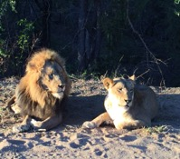
Kruger National Park: One of Africa’s largest game reserves. Its high density of wild animals includes lions, leopard, elephant, rhino and buffalo as well as many smaller mammals, reptiles and birds. Here we deepen our immersion into the animal kingdom as we have the rare opportunity to walk with experienced rangers in the wild. This gives us the opportunity to learn about tracking, and to absorb our senses into the tastes, sounds and sights of the wilderness up close. Our camp will be the Rhino Walking Safari camp.

White Lions: We have the privilege of spending two nights on the sacred land of Tsau, home to the White Lions of Timbavati. This rare opportunity gives a first hand experience of these sacred animals in their natural home.

Blyde River Canyon: Our final three nights will be spent at the foot of the Blyde River Canyon, the third largest canyon in the world. Our lodge is in a wildlife conservancy with a view towards the Blyde Canyon. We’ll explore both the top and bottom of the canyon and have time to relax as well as shop at the local shops and markets.
Many of the sites we visit lie on the Nilotic meridian, a ley line that runs through the length of Africa, connecting many sacred sites from the Giza plateau to those in Southern Africa.

Due to the nature of our walking safari, this journey is limited to 8 people.
A medium level of fitness is required for the hike and walking safari.

Itinerary
Day 1: Tues 26th Sept Arrive in Cape Town by midday. You will be collected at the airport and transferred to our hotel, the Clarendon Bantry Bay which has breathtaking views of the Atlantic Ocean, sumptuous breakfasts and afternoon teas. Welcome dinner in the evening at our hotel.

Day 2: Wed 27th Sept Visit Table Mountain, one of the seven natural wonders of the world by cable car. Lunch is on your own after the visit with the afternoon to rest, shop or visit Kirstenbosch Gardens. Dinner at a local restaurant.

Day 3: Thurs 28th Sept Exploring the Pathways of the Sun is a wonderful morning discovering the sacred space and fauna and flora in the mountains of Cape Town – a hike to Ascension and Burial Caves. Late lunch and afternoon to relax. Dinner at local restaurant.

Day 4: Fri 29th Sept Peninsular Tour of Cape Town which includes the Cape of Good Hope Nature Reserve, Cape Point, Simonstown and Boulders Beach Penguin Colony. Arrive back at our hotel late afternoon. Dinner at our hotel.
Those not joining us in Cape Town will arrive in Johannesburg on this day, be collected at the airport and taken to our hotel for a restful evening.

Day 5: Sat 30th Sept Early morning flight from Cape Town to Johannesburg where we book into our boutique hotel in the Rosebank area. We circle as a group, and optional visit to the Origins Centre and shopping. Lunch on own. Circle and dinner at our hotel.

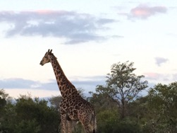
Day 6: Sun 1st Oct Depart Johannesburg early for the province of Mpumalanga. We visit the quaint village of Kaapsehoop and explore sacred sites in the area. Arrive at Tomjachu Bush Lodge late afternoon.

Day 7: Mon 2nd Oct Late morning guided bush walk where we’ll have the opportunity to prepare for our animal encounters and communication with various antelope, zebra and giraffe. Picnic lunch and then walk back to our accommodation for an afternoon to swim, circle and relax.

Day 8: Tues 3rd Oct Depart for the Kruger National Park, Rhino Post Lodge where we will spend our first night. After driving through the park (snack lunch on own), and reaching our destination, we’ll have a late afternoon game drive followed by dinner.

Day 9: Wed 4th Oct After an early morning game drive and brunch, we transfer across to the Rhino Walking Safaris camp where we will stay in African explorer style luxury tents, each with en-suite shower. From here we go on walks and drives with 2 highly experienced trail rangers.
There will also be an opportunity to spend the night under the stars on the Sleep Out Decks, should you wish.

Day 10: Thurs 5th Oct Kruger National Park, Rhino Walking Safaris camp – early morning and evening walks and game drives with rangers. Time to relax in the middle of the day.

Day 11: Fri 6th Oct Early morning game walk followed by breakfast. Depart Rhino Safari camp, and drive through Kruger National Park to Tsau, home of the White Lions of Timbavati.
Circle, briefing and depart for lion monitoring. Dinner back at Unicorn camp
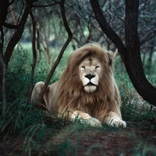
Day 12: Sat 7th Oct Early morning lion monitoring and back to camp for breakfast. Time to circle and relax, lunch and guided walk to the crystal Star Lion. Early evening lion monitoring and dinner back at camp.

Day 13: Sun 8th Oct Early morning lion monitoring and back to camp for breakfast. Late morning departure for lunch and check into Khaya Ndlovu Manor House. Afternoon to settle in and relax. Dinner at Manor House.

Day 14: Mon 9th Oct After breakfast we take a tour to the top of the Blyde River Canyon to meditate, returning for lunch at a restaurant overlooking the canyon, where there will also be shopping opportunities. Afternoon to relax and dinner at the Manor House.
.
Day 15: Tues 10th Oct Morning exploring at the bottom of the Blyde River Canyon with a boat ride and walk to a waterfall.
Return for a late lunch and closing circle.
Final farewell dinner.

Day 16: Wed 11th Oct Late morning departure to Hoedspruit airport for flight to Johannesburg airport, arriving at 3pm.
Evening flights home.

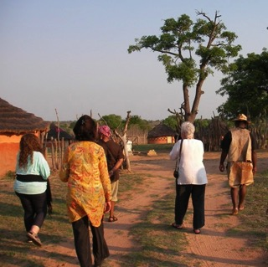

Pricing

- The cost of this tour is $6600.00pp sharing for the entire trip.
- $5600 if you will only be joining for us from the 29th Sept (Johannesburg & Mpumalanga)
- Deposit of $1000.00 is due when booking and is non-refundable.
- Balance of payment for the trip is due not later than August 5th 2017
- South Africa accepts major credit cards in most lodges, restaurants and shops, and ATM’s are readily available.
The tour includes:
- All hotel & lodge accommodations and transport/flights in South Africa
- All entrance fees & most gratuities
- Transportation and transfers to and from the airport on arrival & departure.
- Most meals

It does not include:
- Entry visa if you need to pay for one
- Travel Insurance & Cancellation insurance (both are mandatory)
- Drinks and items of a personal nature eg. laundry
- Hotel accommodations for extra nights should you want to arrive early or stay a little longer. We are happy to arrange these for you.

Please note:
When booking your international flight for this trip, you would fly
into Cape Town and out of Johannesburg, if you are joining us in Cape Town.
If you are joining us in Johannesburg, your international flights will be in and out of Johannesburg.

To sign up or for more information please email: ruth@mysticalplaces.org

Ruth Underwood is a mystic and retreat facilitator who spent her early years living in mostly rural settings in Uganda and South Africa where her deep sense of connection to the soul of Africa was formed.

She has spent most of her career working with non-profits in South Africa, is a yoga and meditation teacher, offers counseling and processing techniques, and holds a deep space of oneness for others on their journey.

Ruth and has travelled to and led journeys to a number sacred sites around the world, and she has a particular connection with the Nilotic meridian in Africa and all the sites along it.

Bottom of Form
To sign up or for more information contact:

Ruth Underwood

